1. Discuss the significant difference between the syntactic rules of HTML and those of XHTML.
2. Create an HTML document that has a form with the following controls:
3. A text box to collect the user’s name
4. Two checkboxes, one each for the following items:
5. Four 25W light bulbs for $2.39
6. Eight 25W light bulbs for $4.29
7. A collection of three radio buttons that are labelled as follows:
8. Visa
9. Master Card
10. Discover
11. What is the purpose of a MIME type specification in a request-response transaction between a browser and a server?
12. What are the different image formats used for representing images?
13. Which protocol is used for web communication? Describe two phases of communication between client and server using this protocol
14. Write the HTML code to generate a Web Page in the format given below :

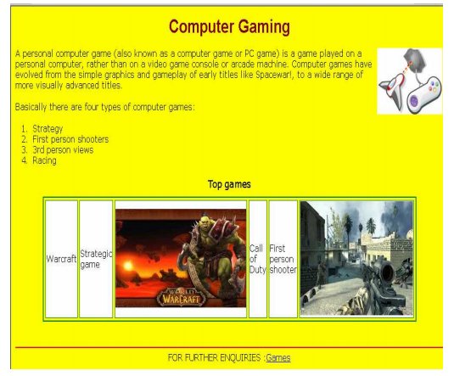

Consider the following while writing the HTML code

• Background of page is yellow

• Title of the page is “gaming”

• Text of whole document is verdana

• Heading of the page is maroon and arial bold

• Image used is “image1.jpg”

• border of table is green and of size 2

• background colour of table is white

• Image used in the table is “war.jpg” and “call.jpg”

• Horizontal line colour is black

• Bottom link is “game.html”